Main Master Slave IsoSPI configuration with detailed analysis on pin setup
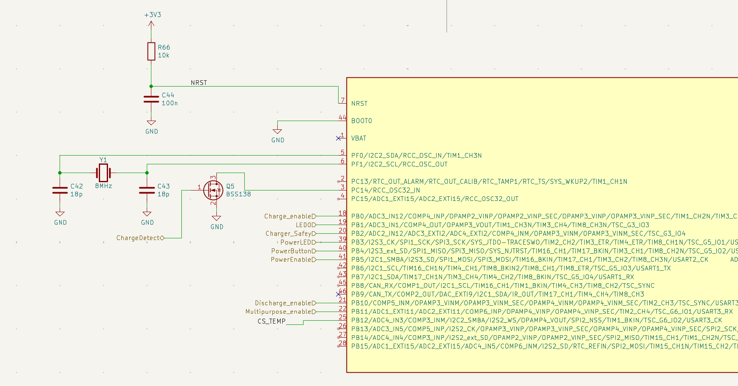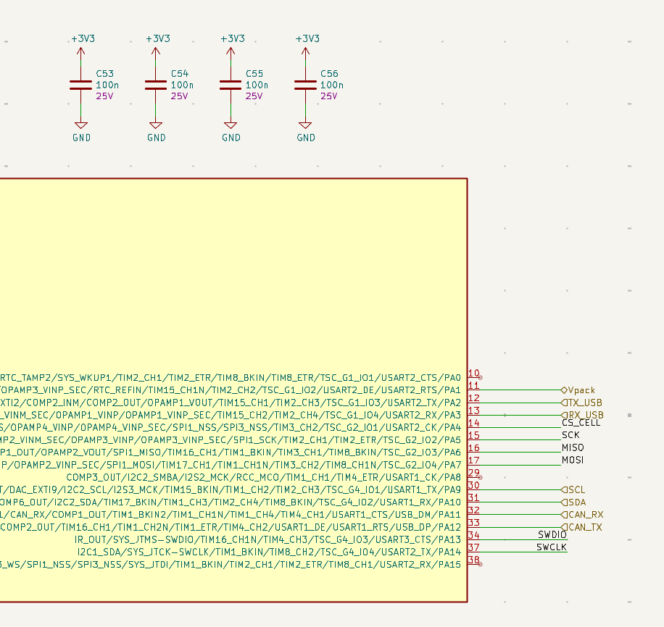
Fig 1 & 2. Master board STM32 pin configuration
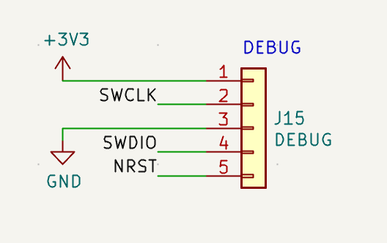
Fig 3. Flashing/Debug input connector

The STM32F303 is the master-board controller. It runs the BMS state machine, communicates with both isoSPI chains, reads local analogue/digital status signals, controls enable/safety outputs, and provides CAN/USB/debug interfaces. It is powered from +3V3, uses an 8 MHz HSE crystal, boots from user Flash with BOOT0 tied low, and is programmed/debugged through SWDIO/SWCLK.
Signal | STM32 pin | Type | Firmware role
CS_CELL | PA4 | SPI CS output / GPIO output | Selects the cell-chain LTC6820. Active-low chip select.
CS_TEMP | PB12 | SPI CS output / GPIO output | Selects the temperature-chain LTC6820. Active-low chip select.
SCK | PA5 | SPI bus | Shared SPI clock to both LTC6820 bridges.
MISO | PA6 | SPI bus | Shared SPI data from selected LTC6820 back to STM32.
MOSI | PA7 | SPI bus | Shared SPI data from STM32 to selected LTC6820.
Vpack | PA1 | ADC input | Load-side HV bus measurement after contactors/precharge.
ChargeDetect | PC14 | GPIO input | Charger present / charger wake reason.
Charge_enabled | PB0 | GPIO output | Charge permission/control output.
LED0 | PB1 | GPIO output | Status LED / indicator output.
Charger_Safety | PB2 | GPIO output | Charger safety/permission output.
PowerLED | PB3 | GPIO output | Power/status LED output.
PowerButton | PB4 | GPIO input | User power-button monitor input.
PowerEnable | PB5 | GPIO output | Firmware power latch / keep-alive output.
Discharge_enable | PB10 | GPIO output | Firmware discharge permission into the shutdown circuit. Downstream signal is active-low through the MOSFET stage. This is not a direct discharge relay driver.
Multipurpose_enable | PB11 | GPIO output | Firmware permission output into shutdown circuit. Downstream signal is active-low through the MOSFET stage. This replaces the old ENNOID precharge meaning and must not be used as a precharge relay output.
TX_USB | PA2 | UART TX | USB debug/config UART transmit to CP2104.
RX_USB | PA3 | UART RX | USB debug/config UART receive from CP2104.
SCL | PA9 | I²C SCL | I²C clock for ISL28022 / local I²C devices.
SDA | PA10 | I²C SDA | I²C data for ISL28022 / local I²C devices.
CAN_RX | PA11 | CAN RX | Vehicle CAN receive.
CAN_TX | PA12 | CAN TX | Vehicle CAN transmit.
SWDIO | PA13 | Debug | Serial Wire Debug data/programming.
SWCLK | PA14 | Debug | Serial Wire Debug clock/programming.
NRST | NRST pin | Reset | Active-low MCU reset; pulled up by 10 kΩ and filtered by 100 nF.
BOOT0 | BOOT0 pin | Boot config | Tied low, so MCU boots from user Flash.
HSE crystal | PF0/PF1 | Clock | 8 MHz external crystal input/output.

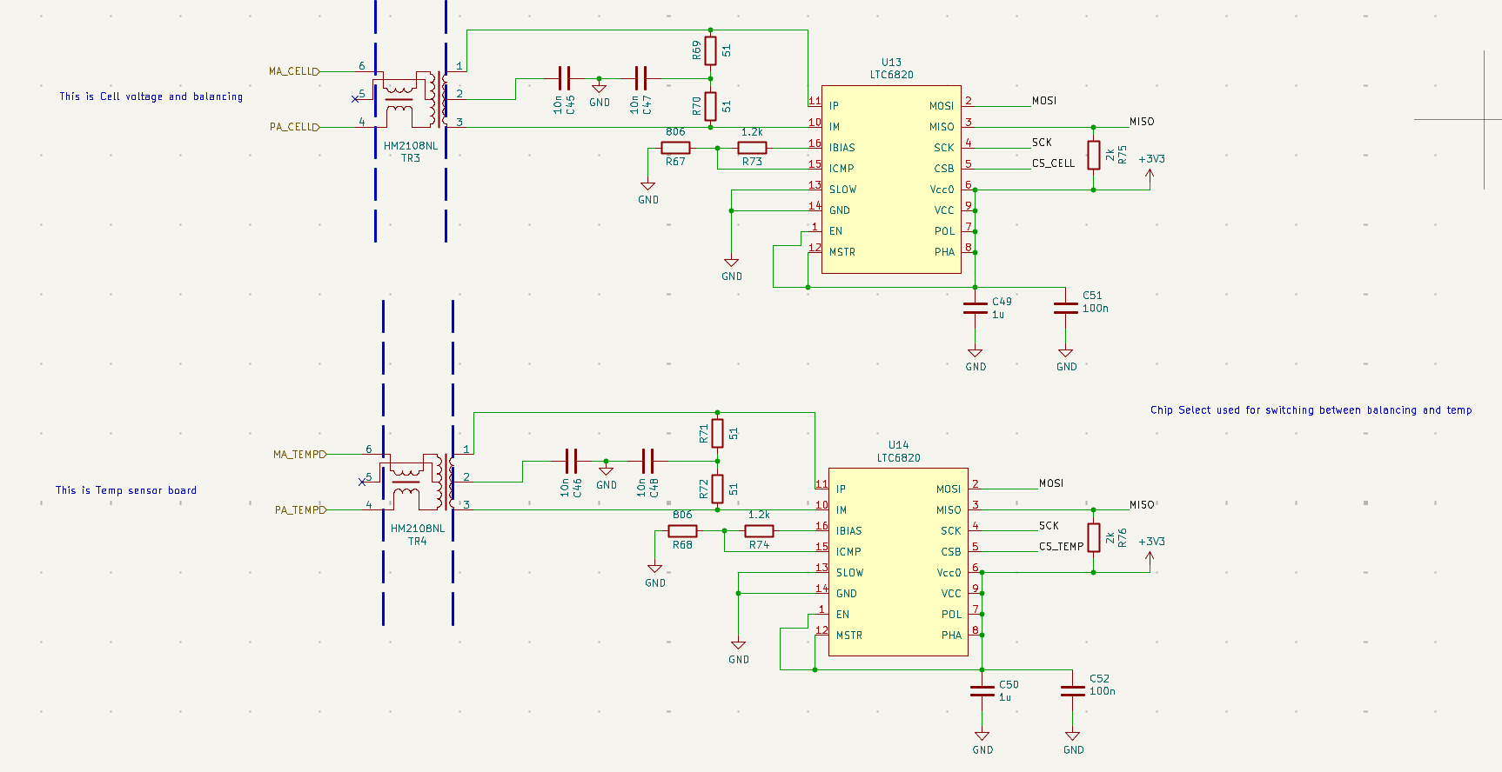
Fig 4. Master LTC6820 Cell and Temp Configuration

Each LTC6820 converts the STM32’s 3.3 V SPI bus into transformer-coupled isoSPI. The cell and temperature chains use separate LTC6820 bridges with shared SPI lines and independent chip selects, `CS_CELL` and `CS_TEMP`. Firmware must assert only one chip select at a time. Both bridges are configured as master-side isoSPI devices, with `MSTR` tied high, `VDD/VDDS` tied to +3V3, `PHA/POL` tied high for SPI mode 3, `SLOW` tied low, and `EN` tied low to allow automatic idle/wake behaviour.

The isoSPI bias network uses 1.2 kΩ from IBIAS to ICMP and 806 Ω from ICMP to GND. Since IBIAS regulates to approximately 2 V, total RBIAS is 2.006 kΩ and the bias current is approximately 1 mA. The IP/IM drive current is therefore approximately 20 mA. ICMP is approximately 0.8 V, giving a receiver threshold of approximately ±0.4 V. The transformer-side 51 Ω + 51 Ω network provides roughly 102 Ω differential termination.
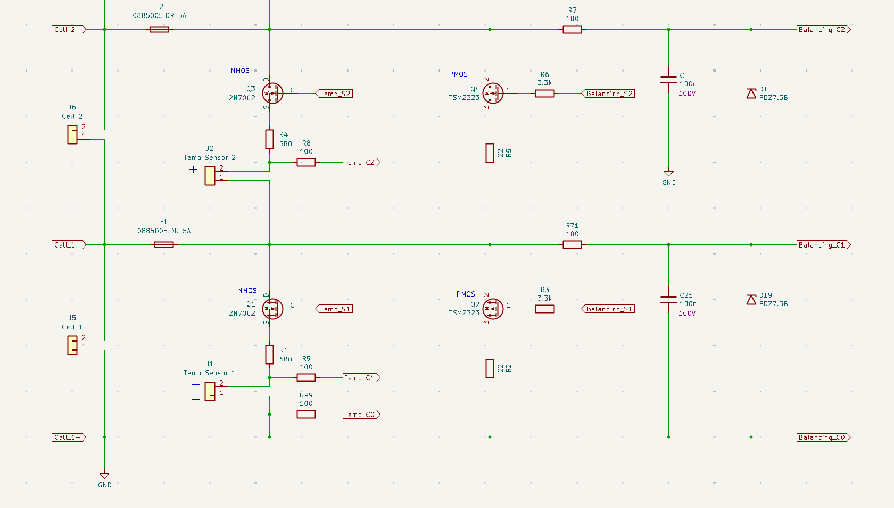
Fig 5. Slave Board full electrical connection schematic

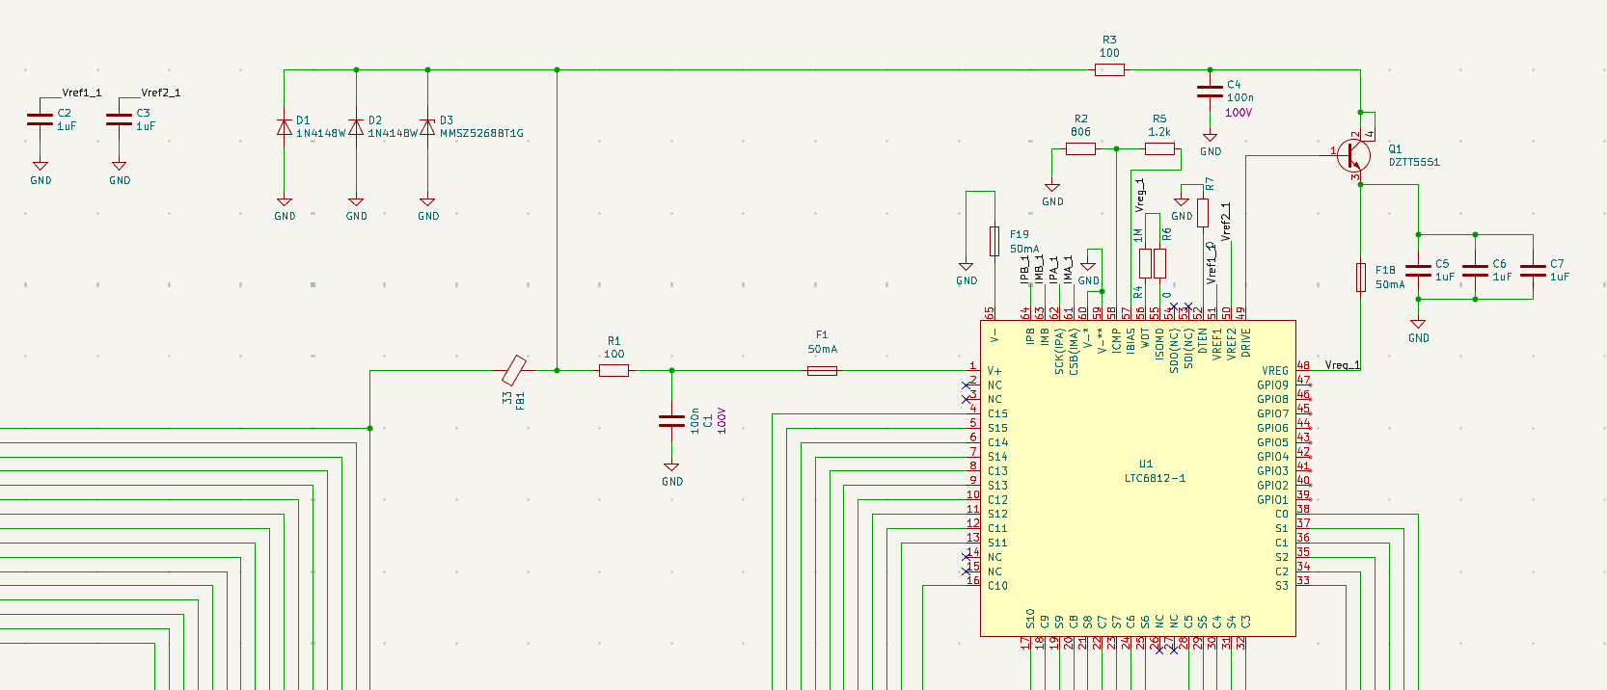
Fig 6. Slave LTC6812 configuration

Each slave LTC6812 floats with its local cell segment. `V+` and `V−` define the local stack supply domain and are not referenced to MCU ground. `C0–C15` measure differential cell/sensor voltages. On the cell-voltage chain, these are real cell voltages and `S1–S15` provide passive balancing control. On the temperature chain, the same measurement inputs are treated as analogue temperature-sensor voltages and S pins are used as an enable/disable switch
Temperature Measurement Slave Chain
The temperature chain uses a separate LTC6812 daisy chain from the cell-voltage chain. It is not used for balancing.
Each Enepaq temperature sensor behaves as a temperature-variable shunt reference. The sensor is current-limited through a 680 Ω path and its voltage is read by the LTC6812 C-input pair. The corresponding LTC6812 S output controls a MOSFET that enables the sensor-bias current only during measurement. After measurement, the S outputs are disabled to minimise parasitic discharge.
Firmware sequence:
1. select CS_TEMP
2. enable the required TEMP-chain S outputs as sensor-bias enables
3. allow settling based on RC time constant
4. start LTC6812 conversion
5. read C-input voltages
6. disable TEMP-chain S outputs
7. convert sensor voltage to temperature using the Enepaq datasheet table
The TEMP-chain S outputs are not balancing outputs. Cell balancing commands must never target the TEMP chain.
The LTC6812 is configured for isoSPI mode by tying `ISOMD` to `VREG_1` through a 0 Ω link. `IPA/IMA` and `IPB/IMB` form the two daisy-chain isoSPI ports. The bias network again uses 1.2 kΩ + 806 Ω, giving approximately 1 mA IBIAS, 20 mA isoSPI drive current, 0.8 V ICMP, and ±0.4 V receiver threshold. `WDT` is weakly pulled to `VREG_1` through 1 MΩ. `DTEN` is tied to `V−`, disabling the autonomous discharge timer, so balancing timing must be handled by firmware.

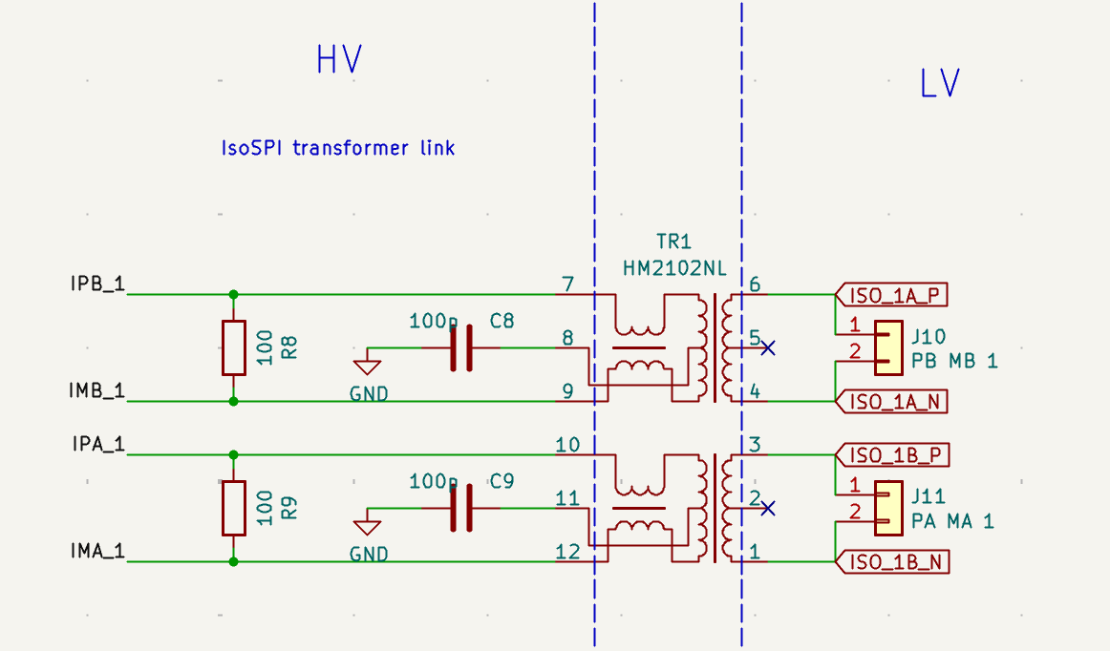
Fig 7. IsoSPI transformer link
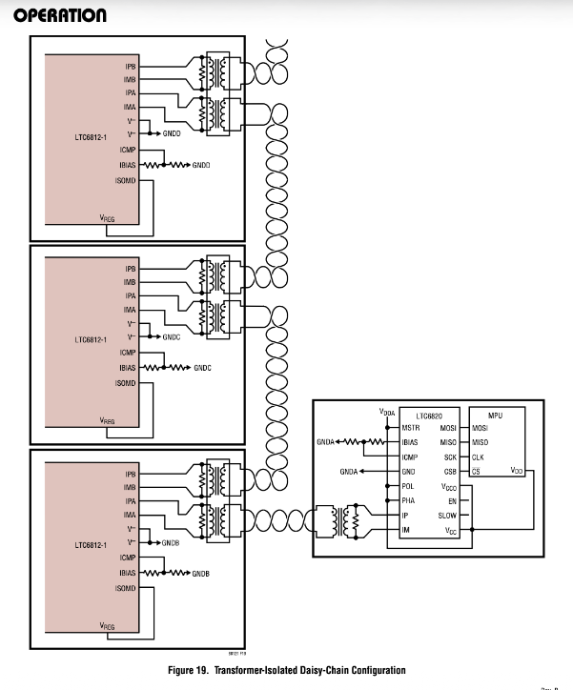
Fig 8. High level topology for daisy chain configuration for master and slave
Master board topology

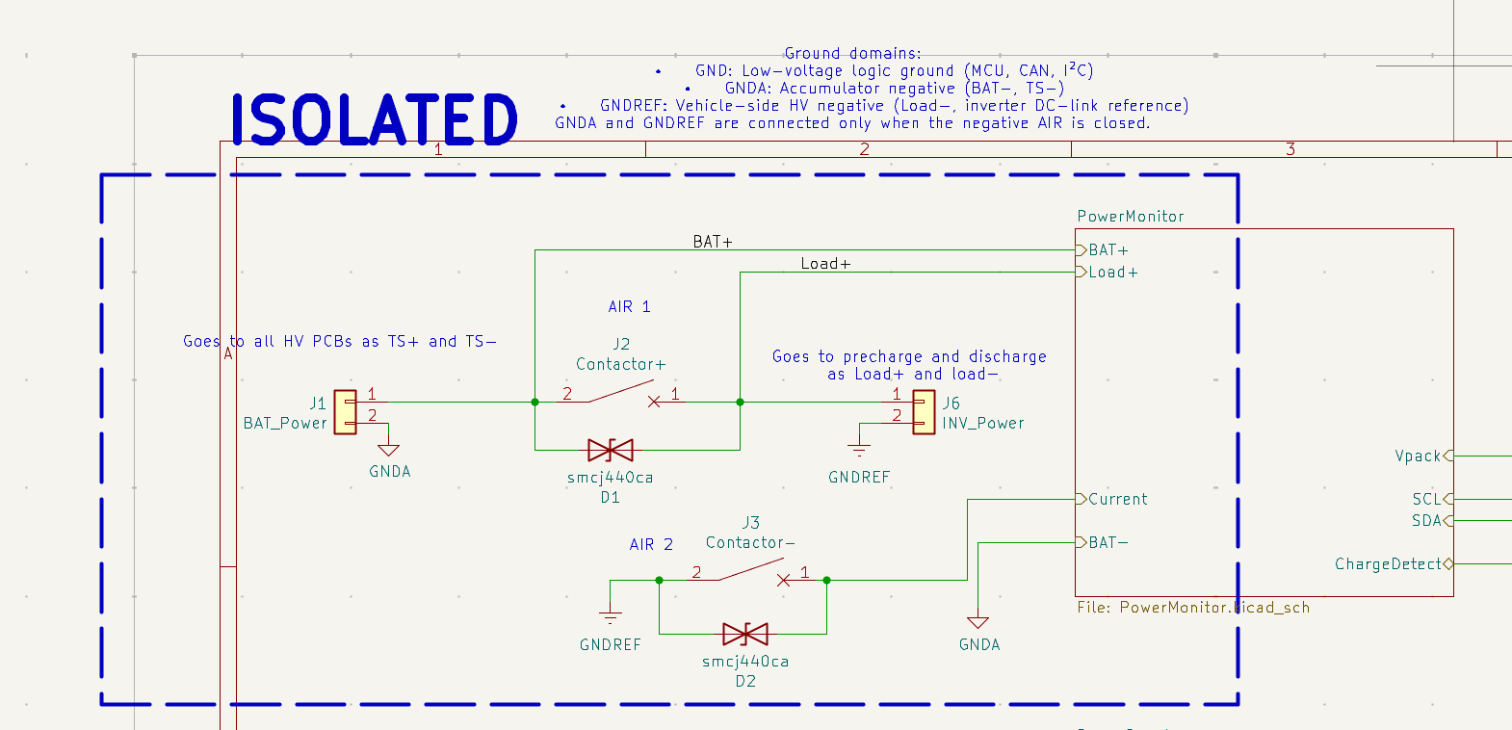
Fig 9. AIR Contact to PowerMonitor subsystem
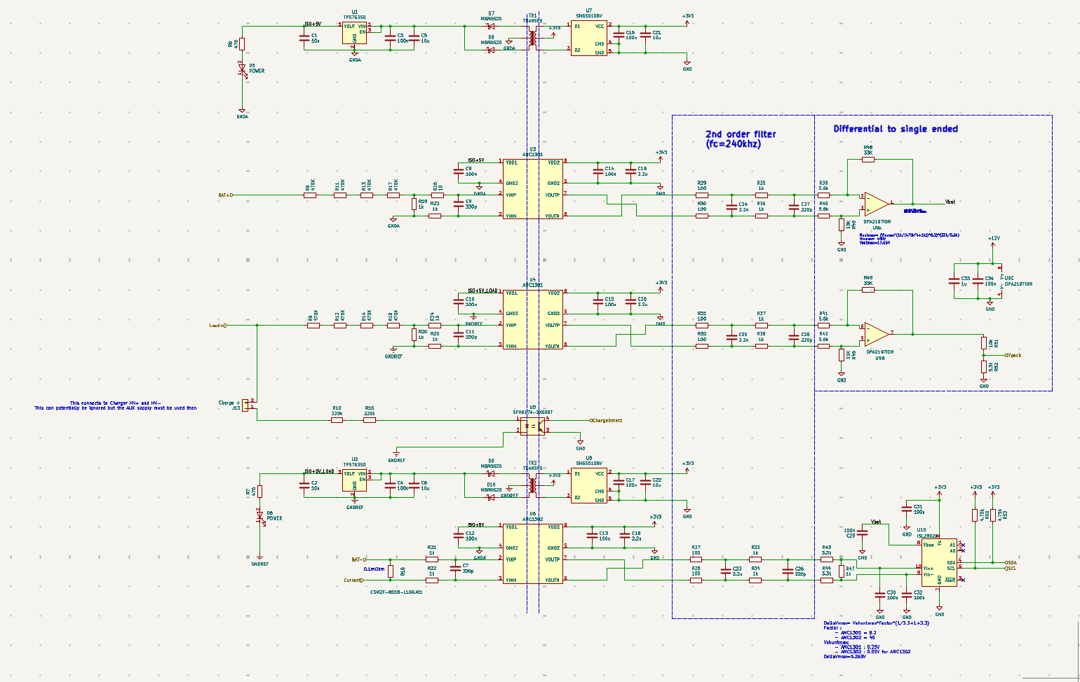
Fig 10. PowerMonitor configuration
The Power Monitor subsystem measures battery-side voltage, load-side voltage, shunt current, and charger presence while maintaining galvanic isolation between HV domains and MCU ground. The relevant domains are `GNDA` for the accumulator side, `GNDREF` for the load/inverter side, and `GND` for MCU logic. `GNDA` and `GNDREF` are only connected when the negative AIR is closed, so `BAT+` and `Load+` must be measured as separate physical nodes.
Measurement | Signal to firmware | Hardware path | Firmware use
Battery-side HV | ISL28022 over I²C | BAT+ divider → AMC1301 → filter → OPA2197 → Vbat → ISL28022 Vbus | Battery-side pack voltage before contactors
Load-side HV | STM32 ADC input Vpack | Load+ divider → AMC1301 → filter → OPA2197 → divider → Vpack | Load-side/precharge bus voltage
Current | ISL28022 over I²C | 0.1 mΩ shunt → AMC1302 → filter/scaling → ISL28022 Vin+ / Vin− | Charge/discharge current
Charger present | STM32 GPIO ChargeDetect | HV charger input → high-value resistors → optocoupler | Charger wake/state input

Both HV voltage dividers use four 470 kΩ resistors over 1 kΩ, giving approximately 1.88 MΩ / 1 kΩ and a divider ratio of about 1/1881. At 500 V this produces approximately 266 mV at the isolation amplifier input. Firmware must convert ADC readings using the complete analogue chain, not just the divider ratio.

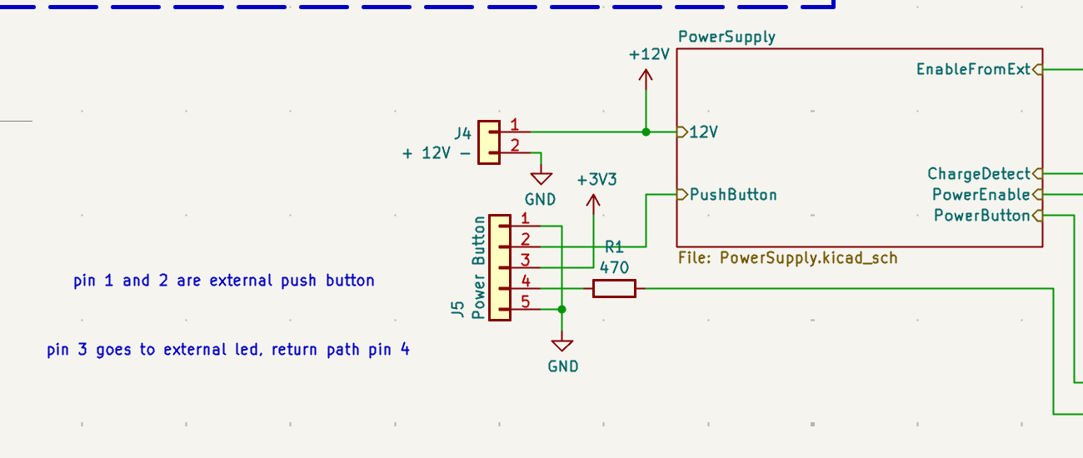
Fig 11. Power supply subsystem
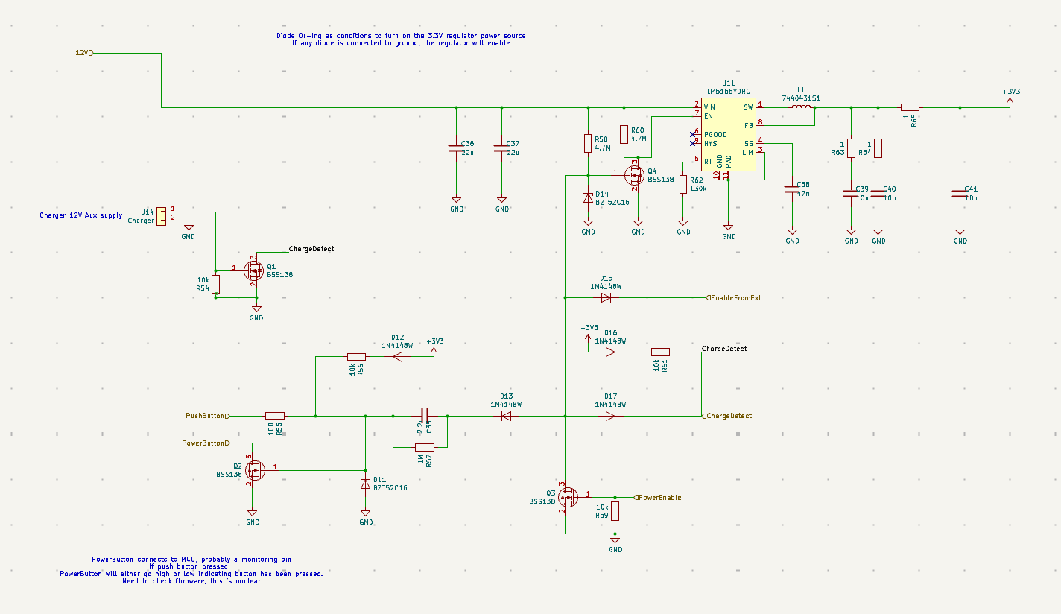
Fig 12. Power Supply Diode-oring network
The Power Supply subsystem generates +3V3 from external +12V using U11, an LM5165 buck regulator. The regulator is not always-on; its enable path is controlled by a diode-OR power-latch network. Valid wake/hold sources include external enable, the power button, charger detection, USB/CAN-related enable request, and firmware-held `PowerEnable`.
The intended sequence is: a hardware wake source enables the regulator, +3V3 rises, the STM32 boots, firmware validates the wake reason and basic system state, then asserts `PowerEnable` to keep the board alive. During shutdown, firmware disables safety/actuator outputs, stores required state, and releases `PowerEnable`.

Signal | Role
PowerButton | user input / wake source
PowerEnable | firmware power latch
ChargeDetect | charger wake source
EnableFromExt | external hardware wake source
EnableRequest | USB/CAN-side wake/request path

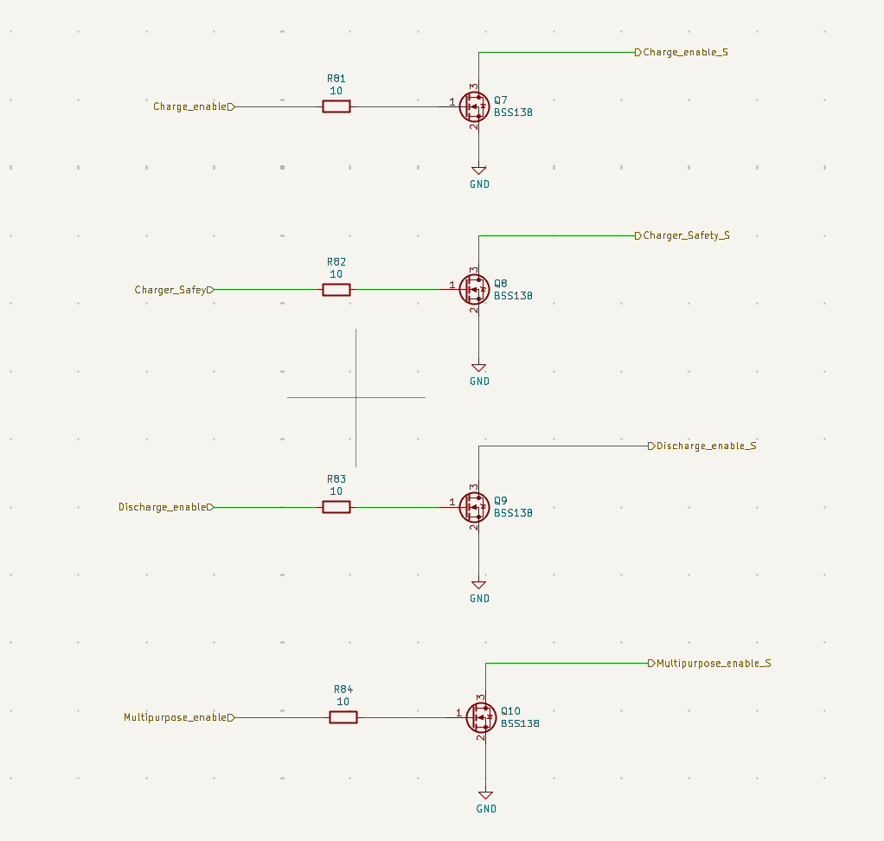
Fig 13. Shutdown conditions
The shutdown circuit combines `Multi_purpose_enable` and `Discharge_enable` using U2, a SN74AHC1G02 two-input NOR gate. Both inputs are pulled up to +5 V through 10 kΩ resistors, so the default state is inactive unless the BMS actively pulls the signals low. The NOR output is `AMS_OK`, so `AMS_OK` is high only when both inputs are low. These signals must therefore be treated in firmware as active-low permissions: `Multi_purpose_enable` means the master/BMS is alive and healthy, while `Discharge_enable` means the pack is safe to discharge.
AMS_OK = !Multi_purpose_enable && !Discharge_enable on the shutdown circuit
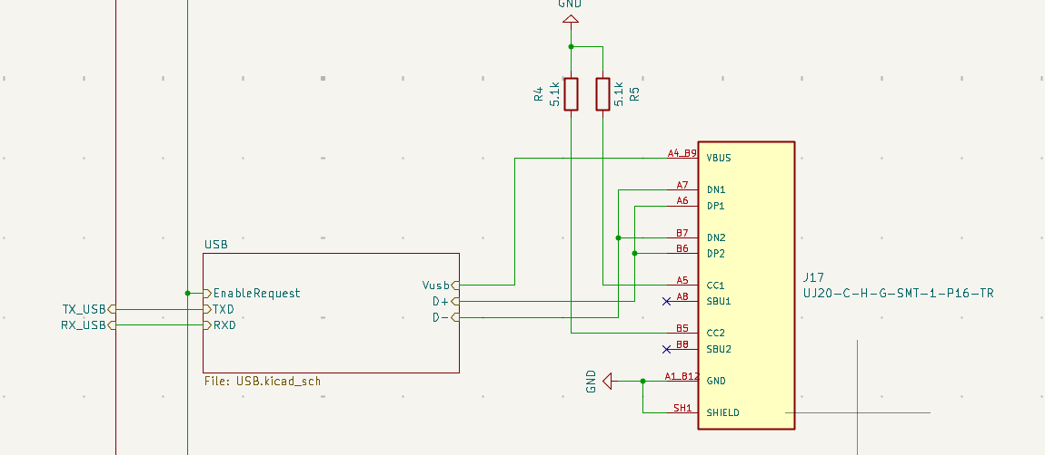
Fig 14. USB port
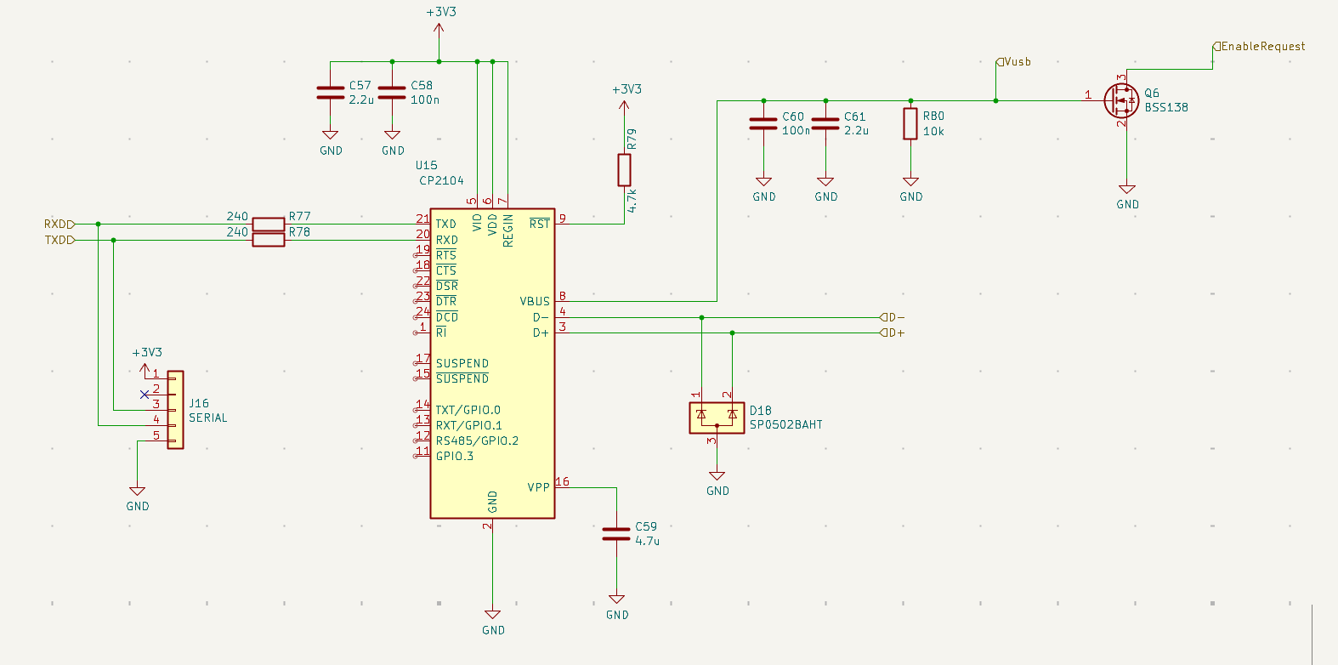
Fig 15 USB to UART bridge

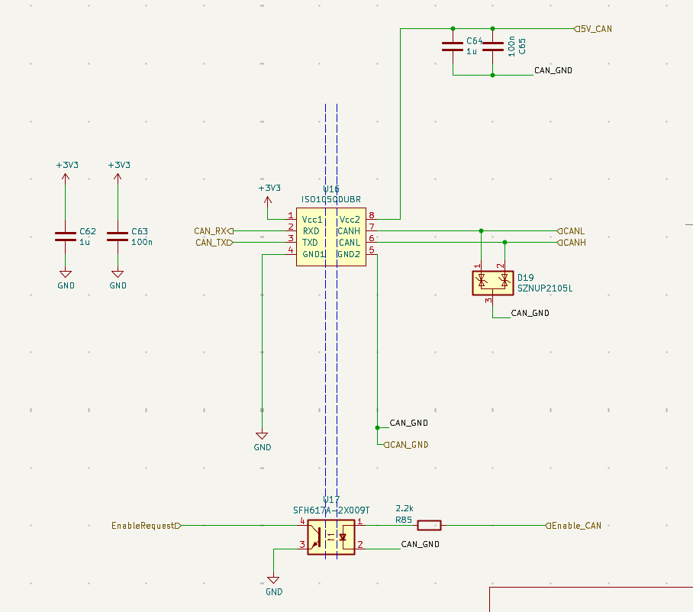
Fig 16. CAN transceiver
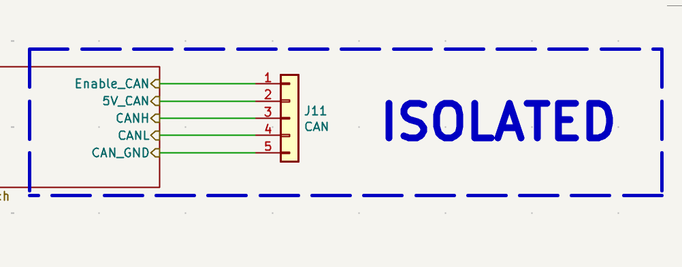
Fig 17. CAN ports

USB is provided through a CP2104 USB-to-UART bridge and should be treated as a debug/configuration/logging interface. USB VBUS can also generate an enable request, so plugging in USB may wake the BMS. This path is not safety-critical and must not be used as sole authority for charge/discharge decisions.
CAN is provided through an isolated ISO1050 transceiver. The STM32 side uses `CAN_RX`/`CAN_TX` referenced to MCU ground, while the bus side uses isolated `5V_CAN`, `CAN_GND`, `CANH`, and `CANL`. `Enable_CAN` is driven across an optocoupler from `EnableRequest`, allowing the MCU to request or indicate CAN-side enable state without tying MCU ground to CAN ground.

Hardware Changes from ENNOID Design

Additional ISOSPI chain for temp sensing according to enepaq cells added. Cooling, precharge relay, and direct discharge relay control removed. Switched to generic mosfet control signals to the shutdown circuit. USB type A changed to USB type C. buzzer removed. OLED removed. Thermistor GPIO readings removed from slave boards.

minimum firmware fault table
The current migrated firmware implements a centralized conservative fault model. The table below describes the intended detection source and permission effect; thresholds and final vehicle policy still require hardware validation and safety review.
Fault condition | Detection source | Firmware response / permission effect
Cell OV soft | CELL LTC6812 voltage stats/config threshold | blocks charge
Cell OV hard | CELL LTC6812 voltage stats/config threshold | critical fault, blocks MasterOk/charge/discharge as configured
Cell UV soft | CELL LTC6812 voltage stats/config threshold | blocks discharge
Cell UV hard | CELL LTC6812 voltage stats/config threshold | critical fault
Cell read invalid | LTC6812 PEC/missing response | blocks permissions conservatively
Cell open-wire | LTC6812 ADOW diagnostic | blocks balancing and relevant permissions
Temperature read invalid | TEMP LTC6812 read/conversion validity | blocks temp-dependent permissions
Temperature overlimit | Enepaq converted temp | blocks charge/discharge depending policy
ISL read invalid | ISL28022 I²C failure | blocks power-monitor-dependent decisions
Vpack read invalid | PA1 ADC failure/out of range | blocks precharge/discharge validation
Precharge timeout | Vbat/Vpack relationship over time | fault, do not proceed to load enabled
Welded contactor suspicion | Vpack high when expected discharged | fault
Internal fatal | firmware/state-machine fatal path | deassert permissions

Truth Table
Condition | MasterOk | DischargePermission | ChargePermission | ChargerSafety
Boot/reset/default | off | off | off | off
Cell read invalid | off | off | off | off
Open-wire fault | off/block | off/block | off/block | off/block
Temp invalid | depends on masks, conservative block | block if required | block if required | block if charge blocked
Soft UV | maybe MasterOk allowed | off | allowed if otherwise safe | allowed if charging safe
Soft OV | maybe MasterOk allowed | allowed if otherwise safe | off | off
Hard OV/UV | off | off | off | off
Precharge incomplete | conditional | off | off | off
Load enabled and healthy | on | on | optional | optional
Charging healthy | maybe off/on depending shutdown role | off | on | on
Error/power-down | off | off | off | off

Appendix: Original ENNOID Firmware Gap Analysis
This appendix documents the original gap analysis before the migration. It is retained for traceability only. It no longer describes the current firmware state.
Existing Firmware State
A. Architecture
Key refs: Main/main.c (line 30), modOperationalState.c (line 39), modPowerElectronics.c (line 22), mainDataTypes.h (line 479)
main() does HAL_Init(), SystemClock_Config(), power-latch on via modPowerStateInit(P_STAT_SET), starts IWDG, loads config/SoC from EEPROM, then inits commands/UART/CAN/effects/power-electronics/operational-state/HiAmp in that order. The superloop is modEffectTask(), modPowerStateTask(), modOperationalStateTask(), modUARTTask(), modCANTask(), modHiAmpTask(), watchdog refresh, and modPowerElectronicsTask(); on each successful measurement pass it runs modStateOfChargeProcess().
State machine states are OP_STATE_INIT, CHARGING, PRE_CHARGE, LOAD_ENABLED, BATTERY_DEAD, POWER_DOWN, EXTERNAL, ERROR, ERROR_PRECHARGE, BALANCING, CHARGED, FORCEON. Existing protection is centered in modPowerElectronicsSubTaskVoltageWatch(): soft UV blocks discharge, soft OV blocks charge, hard UV/OV eventually sets PACK_STATE_ERROR_HARD_CELLVOLTAGE, which modOperationalStateTask() escalates to OP_STATE_ERROR. Precharge timeout is handled in OP_STATE_PRE_CHARGE. Temperature protection is not active: modPowerElectronicsTask() comments out modPowerElectronicsSubTaskTemperatureWatch() and only computes temp stats/throttles. Comms interfaces present are USART2 packet protocol, CAN, SPI1 for LTC6803, I2C1/I2C2, plus OLED/buzzer/HiAmp support.
B. Hardware Mapping
Primary pin refs: mxconstants.h (line 44), stm32f3xx_hal_msp.c (line 126), driverHWPowerState.c (line 3), driverHWSwitches.c (line 3)
New signal | Existing firmware ref | Current config | Match | Required change
CS_CELL | LTC_CS_Pin, driverSWLTC6803 | PA4, GPIO CS for SPI1 | Yes | Reuse as cell-chain CS.
CS_TEMP | SDC_CS_Pin only | PB12, currently SD-card/SPI2 CS in CubeMX, unused by BMS logic | No | Repurpose PB12 as second LTC6820 CS and remove SD-card meaning.
SCK/MISO/MOSI | LTC_SCK/MISO/MOSI, driverHWSPI1Init() | PA5/PA6/PA7, SPI1 | Yes | Reuse bus. Note ambiguity: runtime driver is mode 3, but CubeMX MX_SPI1_Init() is CPHA=1EDGE, not mode 3.
Vpack | VoutSense_Pin, driverHWADCGetLoadVoltage() | PA1 ADC1_IN2 | Yes | Reuse as load-side/precharge bus voltage; recalibrate for new analogue chain and rename semantics.
ChargeDetect | P_STAT_CHARGE_DETECT, ChargeDetect_Pin | PC14 input | Yes | Likely reusable as-is.
PowerButton | P_STAT_BUTTON_INPUT, PowerButton_Pin | PB4 input pull-up in HW driver | Yes | Reuse, verify active level against new board.
PowerEnable | P_STAT_POWER_ENABLE, PowerEnable_Pin | PB5 output | Yes | Reuse latch logic.
Charge_enabled | SWITCH_CHARGE, ChargeEnable_Pin | PB0 output | Pin matches | Rebind semantics to charge permission output; verify polarity.
Charger_Safety | SWITCH_DRIVER, SwitchEnable_Pin | PB2 output | Pin matches, role does not | Change from “FET driver enable” to charger safety/permission.
Discharge_enable | SWITCH_DISCHARGE, DischargeEnable_Pin | PB10 output | Pin matches, polarity/role do not | Must become active-low shutdown permission, not active-high discharge relay/FET control.
Multipurpose_enable | SWITCH_PRECHARGE, PreChargeEnable_Pin | PB11 output | Pin matches, role does not | Must replace precharge function with active-low master/AMS permission.
TX_USB/RX_USB | BOOTLOADER_TX/RX, driverHWUART2 | PA2/PA3, USART2 | Yes | Reuse UART, rename from bootloader/OEM meaning to USB debug UART.
SCL/SDA | ISL_SCL/SDA, driverHWI2C2 | PA9/PA10, I2C2 | Yes | Reuse physical pins; keep/rename I2C2 abstraction as needed.
CAN_RX/CAN_TX | HAL_CAN_MspInit, modCANInit | PA11/PA12, CAN AF9 | Yes | Reuse.
ISL28022 | driverSWISL28022, ISL28022_MASTER_BUS=2 | Reads on I2C2 | Partly | Reuse driver shell, but improve init, error returns, scaling, and explicit Vbat/current semantics.
LTC6812/LTC680x driver | driverSWLTC6803 only | Single-chain LTC6803, 12-cell API | No | Replace or heavily refactor for LTC6812 + 15 channels + 2 chains.
cell balancing | modPowerElectronicsSubTaskBalaning(), driverSWLTC6803EnableBalanceResistors() | Single mask on one chain | Partly | Reuse algorithm ideas only for cell chain; hard-block balancing on temp chain.
temperature measurement | driverSWLTC6803ReadTempVoltages() + NTC conversion | 2 external + 1 internal LTC6803 temps + local STM32 NTC | No | Replace with second LTC6812 analogue-voltage chain and new conversion model.
C. Driver Reuse Assessment
Driver refs: driverSWLTC6803.h (line 9), driverSWLTC6803.c (line 6), driverHWSPI1.c (line 5)
- It supports 12 cells per IC only: driverSWLTC6803ReadCellVoltages(...[12]), NoOfCellsPossibleOnChip 12, default config noOfCells = 12.
- It does not support 15 cells per IC.
- It does not support 5 ICs in practice. driverSWLTC6803Init(..., totalNumberOfLTCs) stores a count, but modPowerElectronics.h hardcodes TotalLTCICs 1, the pack state array holds only 12 cells, and several read paths use [1][...] buffers.
- It does not support two independent isoSPI chains or two CS lines; all SPI coupling is hardwired to LTC_CS_Pin.
- SPI mode 3 is supported by driverHWSPI1Init() (CPOL=HIGH, CPHA=2EDGE), which matches LTC6820 mode 3. CubeMX SPI1 config does not match, so there is a split-brain risk.
- PEC checking exists in the LTC6803 driver, but callers mostly ignore the boolean return values, so the system does not currently turn PEC faults into a safe-state action.
- Open-wire command enums exist in driverSWLTC6803.h, but there is no call path using them. So diagnostics are not implemented at system level.
- Balancing control exists and writes DisChargeEnableMask on the LTC chain.
- Existing temperature support is old-style LTC6803 aux/thermistor handling plus one local STM32 NTC; that should be replaced, not extended, for a second LTC6812 analogue temp chain.
D. Required Firmware Changes
- Pin/peripheral config changes: add CS_TEMP on PB12; repurpose PB11 from precharge to Multipurpose_enable; repurpose PB2 to Charger_Safety; keep PA1, PA2/3, PA9/10, PA11/12, PC14, PB4, PB5, PB0, PB10; remove OLED/buzzer/SD-card pin assumptions.
- isoSPI/LTC driver changes: replace driverSWLTC6803 with LTC6812-capable code; support 5 devices x 15 measurements; support separate cell/temp chain selectors; enforce “only one CS low at a time”; make comms faults actionable.
- Temperature-chain implementation: add second chain read path, analogue-voltage-to-temperature conversion, indexing/storage for 75 temps, and a hard guard so no balancing/config writes intended for cells reach the temp chain.
- Power monitor / ISL28022 changes: keep ISL over PA9/PA10, but formalize Vbat and current reads, propagate I2C errors, and validate scaling against the new AMC1301/AMC1302 path.
- Shutdown/AMS_OK logic changes: replace legacy charge/precharge/discharge contactor model with active-low permissions on PB11/PB10;
- Removed feature cleanup: delete/disable OLED (modDisplay, driverSWSSD1306, I2C1 use), buzzer (driverHWStatus), SD-card/SPI2, slave thermistor assumptions, and any HiAmp/cooling artifacts not used on the new board.
- CAN/USB changes: CAN pins already match; USB UART already matches electrically but should be renamed away from BOOTLOADER_TX/RX.
- Fault logic changes: add temp-chain comms policy, open-wire handling, precharge Vbat/Vpack mismatch fault, welded-contactor suspicion, ISL I2C fault, and watchdog/fatal behavior that deasserts Multipurpose_enable.
E. Main Risks
- Output polarity is the biggest safety risk: current SWITCH_* logic is active-high, but new Multipurpose_enable and Discharge_enable must be treated as active-low permissions.
- PB11 currently means precharge. Reusing old code unchanged could accidentally drive the shutdown path as if it were a precharge relay.
- PB12 exists only as old SDC_CS_Pin; without a chain abstraction both CS lines could be asserted or left ambiguous.
- The current balancing path is global. If copied naively to dual chains, the temp chain could receive balancing/config writes.
- LTC comms PEC exists but is not turned into a fault response; today a bad PEC can be silently ignored by higher-level logic.
- Open-wire is declared but unused.
- Error_Handler() just loops; there is no explicit deassert of a future Multipurpose_enable.
- SPI config is ambiguous: custom driver is mode 3, CubeMX SPI1 is not. A future refactor could silently break isoSPI comms.
- Current ISL validity logic compares bus voltage to noOfCells * cellVoltageAverage within 1 V; that heuristic may be too brittle for 75 cells and the new analogue chain.
- modPowerElectronicsCheckPackSOA() sets packInSOA = packOutsideLimits, which reads inverted; it is also never the primary shutdown path.
F. Recommended Implementation Order
- Make builds reproducible from one path only. Today the repo is Keil/CubeMX-centric, with .uvprojx and .ioc files but no checked-in GCC/CMake build.
- Update the pin map and rename GPIO abstractions to the new contract.
- Introduce a two-chain isoSPI HAL: shared SPI bus, CS_CELL, CS_TEMP, mutual exclusion.
- Get cell-chain LTC6812 readout working first, with PEC failure surfaced.
- Get temp-chain LTC6812 readout working second, read-only by construction.
- Bring up ISL28022 Vbat/current and verify PA1 Vpack.
- Replace legacy precharge/discharge outputs with explicit shutdown/AMS permission logic and verified polarity.
- Implement the fault table and safe-state actions.
- Validate CAN and USB debug paths after the safety/output changes.
- Run a hardware bring-up checklist: boot defaults, one-CS-at-a-time, cell read, temp read, ISL read, charger detect, power latch, watchdog reset, UV/OV/temp/comms/open-wire fault injection.
Open Questions
- The Enepaq voltage-to-temperature conversion is implemented from the repo-provided datasheet table using lookup/interpolation. The remaining open questions are physical channel mapping, required channel mask, and sensor-bias settling time.The required policy for temp-chain comms faults is still “likely disable charge/discharge or derate; policy TBD”.
- I did not find an existing build script/toolchain lockfile; choosing Keil-only vs generating a GCC/CMake path is an upfront decision.

